|  |  |
| --- | --- |
| **Test Scenario** | Use Case 1 |
| **Test Scenario Description** | History Study Session |
| **Test Environment** | Windows 10 Pro |

|  |  |  |  |  |  |
| --- | --- | --- | --- | --- | --- |
| Step | Action Performed | Input | Expected Result | Actual Result | Results |
| 1 | Click study.jar to run application | N/A | Java GUI opens and presents user with subject choice drop down, quantity of questions available, a textfield to enter amount of questions to study and a Start button. | Java GUI opens and presents user with subject choice drop down, quantity of questions available, a textfield to enter amount of questions to study and a Start button. | Pass |
| 2 | Select History Subject | Dropdown Menu | The subject will now be set to History. | The subject is set to History. | Pass |
| 3 | Set quantity of questions to 3 | Textfield | The textfield should be populated with the number 3. | The textfield is populated with the number 3. | Pass |
| 4 | Press Start | Button | Questions begin to be displayed. | Questions begin to be displayed. | Pass |
| 5 | Select an Answer | Radio Button | Radio Button is selected. | Radio Button is selected. | Pass |
| 6 | Confirm Answer | Button | Answer is accepted and correct answer is displayed. | Answer is accepted and correct answer is displayed. | Pass |
| 7 | Next Question | Button | Next question is displayed. | Next question is displayed. | Pass |
| 8 | Repeat steps 6 through 8. | N/A | Repeat steps 6-8. | Repeat steps 6-8. | Pass |
| 9 | Complete Study Session | Button | A grade will be displayed depending on amount of correct answers. | A grade will be displayed depending on amount of correct answers. | Pass |
| 10 | End application | Button | Application closes without issue. | Application closed without issue. | Pass |

Use Case 1 Requirements Met: 1, 2, 3, 4, 6, 9

|  |  |
| --- | --- |
| **Test Scenario** | Use Case 2 |
| **Test Scenario Description** | Math Study Session |
| **Test Environment** | Raspbian 10 |

|  |  |  |  |  |  |
| --- | --- | --- | --- | --- | --- |
| Step | Action Performed | Input | Expected Result | Actual Result | Results |
| 1 | Click study.jar to run application | N/A | Java GUI opens and presents user with subject choice drop down, quantity of questions available, a textfield to enter amount of questions to study and a Start button. | Java GUI opens and presents user with subject choice drop down, quantity of questions available, a textfield to enter amount of questions to study and a Start button. | Pass |
| 2 | Select History Subject | Dropdown Menu | The subject will now be set to Math. | The subject is set to Math. | Pass |
| 3 | Set quantity of questions to 3 | Textfield | The textfield should be populated with the number 4. | The textfield is populated with the number 4. | Pass |
| 4 | Press Start | Button | Questions begin to be displayed. | Questions begin to be displayed. | Pass |
| 5 | Select an Answer | Radio Button | Radio Button is selected. | Radio Button is selected. | Pass |
| 6 | Confirm Answer | Button | Answer is accepted and correct answer is displayed. | Answer is accepted and correct answer is displayed. | Pass |
| 7 | Next Question | Button | Next question is displayed. | Next question is displayed. | Pass |
| 8 | Repeat steps 6 through 8. | N/A | Repeat steps 6-8. | Repeat steps 6-8. | Pass |
| 9 | Complete Study Session | Button | A grade will be displayed depending on amount of correct answers. | A grade will be displayed depending on amount of correct answers. | Pass |
| 10 | End application | Button | Application closes without issue. | Application closed without issue. | Pass |

Use Case 2 Requirements Met: 1, 2, 3, 4, 6, 9

|  |  |
| --- | --- |
| **Test Scenario** | Use Case 3 |
| **Test Scenario Description** | History Study Session |
| **Test Environment** | Ubuntu 16.04 |

|  |  |  |  |  |  |
| --- | --- | --- | --- | --- | --- |
| Step | Action Performed | Input | Expected Result | Actual Result | Results |
| 1 | Click study.jar to run application | N/A | Java GUI opens and presents user with subject choice drop down, quantity of questions available, a textfield to enter amount of questions to study and a Start button. | Java GUI opens and presents user with subject choice drop down, quantity of questions available, a textfield to enter amount of questions to study and a Start button. | Pass |
| 2 | Select History Subject | Dropdown Menu | The subject will now be set to Geography. | The subject is set to Geography. | Pass |
| 3 | Set quantity of questions to 3 | Textfield | The textfield should be populated with the number 5. | The textfield is populated with the number 5. | Pass |
| 4 | Press Start | Button | Questions begin to be displayed. | Questions begin to be displayed. | Pass |
| 5 | Select an Answer | Radio Button | Radio Button is selected. | Radio Button is selected. | Pass |
| 6 | Confirm Answer | Button | Answer is accepted and correct answer is displayed. | Answer is accepted and correct answer is displayed. | Pass |
| 7 | Next Question | Button | Next question is displayed. | Next question is displayed. | Pass |
| 8 | Repeat steps 6 through 8. | N/A | Repeat steps 6-8. | Repeat steps 6-8. | Pass |
| 9 | Complete Study Session | Button | A grade will be displayed depending on amount of correct answers. | A grade will be displayed depending on amount of correct answers. | Pass |
| 10 | End application | Button | Application closes without issue. | Application closed without issue. | Pass |

Use Case 3 Requirements Met: 1, 2, 3, 4, 6, 9

|  |  |
| --- | --- |
| **Test Scenario** | Error Handling 1 |
| **Test Scenario Description** | Demonstrate Application handles errors |
| **Test Environment** | Windows 10 Pro |

|  |  |  |  |  |  |
| --- | --- | --- | --- | --- | --- |
| Step | Action Performed | Input | Expected Result | Actual Result | Results |
| 1 | Click study.jar to run application | N/A | Java GUI opens and presents user with subject choice drop down, quantity of questions available, a textfield to enter amount of questions to study and a Start button. | Java GUI opens and presents user with subject choice drop down, quantity of questions available, a textfield to enter amount of questions to study and a Start button. | Pass |
| 2 | Select a Subject | Dropdown Menu | The subject will now be set to Geography. | The subject is set to Geography. | Pass |
| 3 | Press Start | Button | Without entering a number of questions press start and a popup notice alerting user appears. | Without entering a number of questions press start and a popup notice alerting user appears. | Pass |
| 4 | Enter number of questions | Textfield | Enter 11 in the textfield and 11 is displayed. | Entered 11 into the number of questions to study field. | Pass |
| 5 | Test max number of questions | Textfield | A popup alerting the user should be displayed. | A popup informing the user that 11 is an invalid number appears. | Pass |
| 6 | Set quantity of questions | Textfield | Enter 1 in the textfield. | Enter 1 in the textfield. | Pass |
| 7 | Press Start | Button | Question populates the GUI. | Question populates the GUI. | Pass |
| 8 | Press Next | Button | Without selecting an answer, press next. A popup should appear alerting the user. | A popup appears alerting the user of lack of answer selection. | Pass |
| 9 | Select an answer | Radio Button | Radio button for select answer is populated. | Radio button for select answer is populated. | Pass |
| 10 | Submit answer | Button | Answer is submitted and correct answer displayed. | Answer is submitted and correct answer displayed. | Pass |
| 11 | Turn in answer | Button | Answer is turned in and scored. | Answer is turned in and scored. | Pass |
| 12 | Exit application | Button | Application closes without issue. | Application closes without issue. | Pass |

Error Handling 1 Requirements Met: 1, 2, 3, 4, 5, 10

|  |  |
| --- | --- |
| **Test Scenario** | Randomized Questions 1 |
| **Test Scenario Description** | Demonstrate Application Randomizes Questions |
| **Test Environment** | Windows 10 Pro |

|  |  |  |  |  |  |
| --- | --- | --- | --- | --- | --- |
| Step | Action Performed | Input | Expected Result | Actual Result | Results |
| 1 | Click study.jar to run application | N/A | Java GUI opens and presents user with subject choice drop down, quantity of questions available, a textfield to enter amount of questions to study and a Start button. | Java GUI opens and presents user with subject choice drop down, quantity of questions available, a textfield to enter amount of questions to study and a Start button. | Pass |
| 2 | Select a Subject | Dropdown Menu | The subject will now be set to Geography. | The subject is set to Geography. | Pass |
| 3 | Enter number of questions | Textfield | Enter 1 in the textfield and 1 is displayed. | Entered 1 into the number of questions to study field. | Pass |
| 4 | Press Start | Button | Questions begin to be displayed. | Questions begin to be displayed. | Pass |
| 5 | Select an Answer | Radio Button | Radio Button is selected. | Radio Button is selected. | Pass |
| 6 | Confirm Answer | Button | Answer is accepted and correct answer is displayed. | Answer is accepted and correct answer is displayed. | Pass |
| 7 | Turn in answer | Button | Answer is turned in and scored. | Answer is turned in and scored. | Pass |
| 8 | Exit application | Button | Application closes without issue. | Application closes without issue. | Pass |
| 9 | Repeat steps 1-8 two additional times | N/A | A different question populates each run. | A different question populates each run. | Pass |

Randomized Questions 1 Requirements Met: 1, 2, 3, 4, 5, 6

Test Case Images:

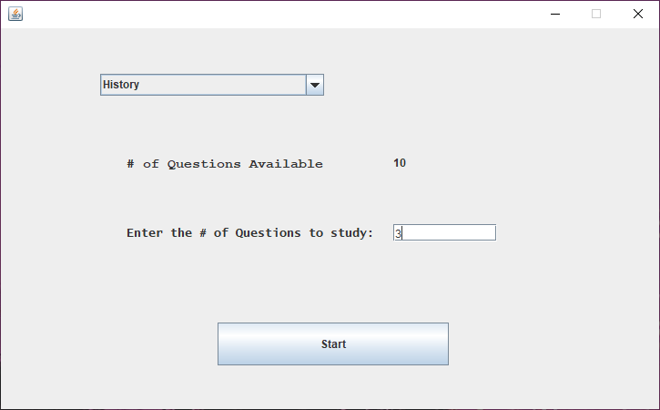

Figure 1 – Use Case 1 Setup

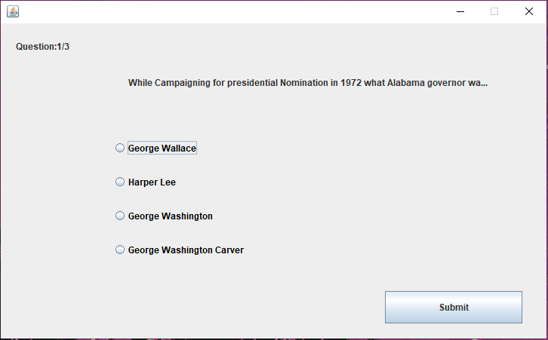

Figure 2 – Question 1/3 without an answer selected for Use Case 1

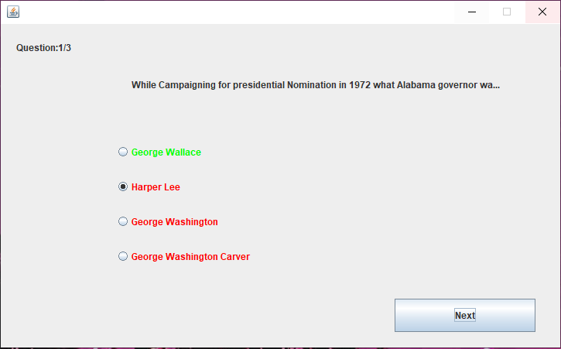

Figure 3 – Question 1/3 with an answer submitted

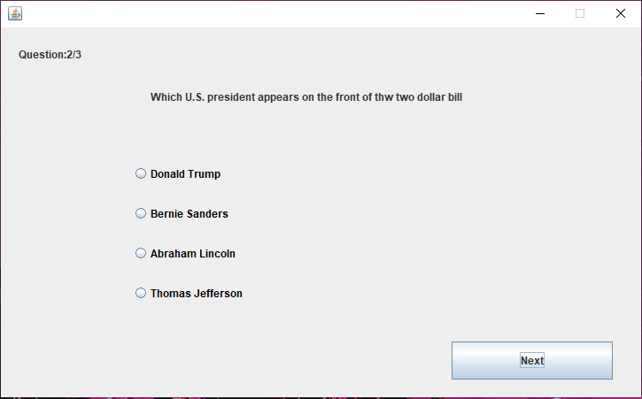

Figure 4 – Question 2/3 without an answer submitted for Use Case 1

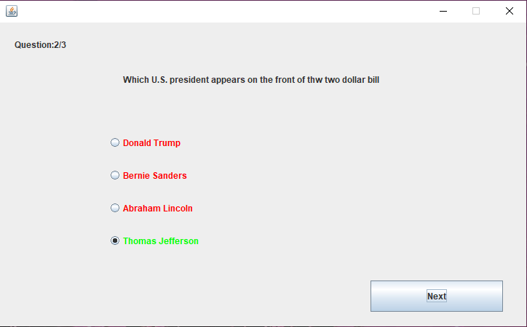

Figure 5 – Question 2/3 with an answer submitted for Use Case 1

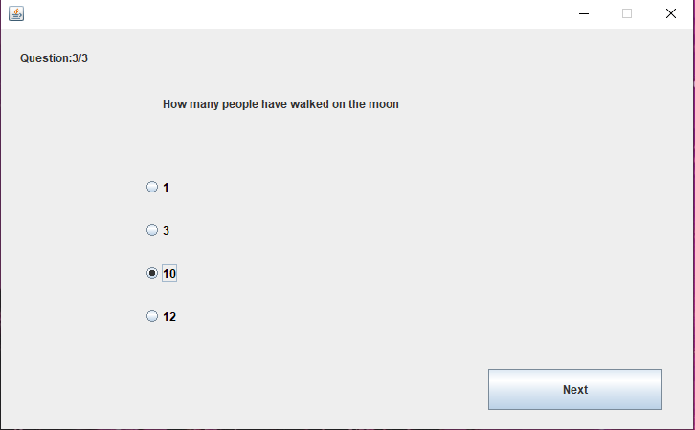

Figure 6 – Question 3/3 with an answer selected but not submitted for Use Case 1

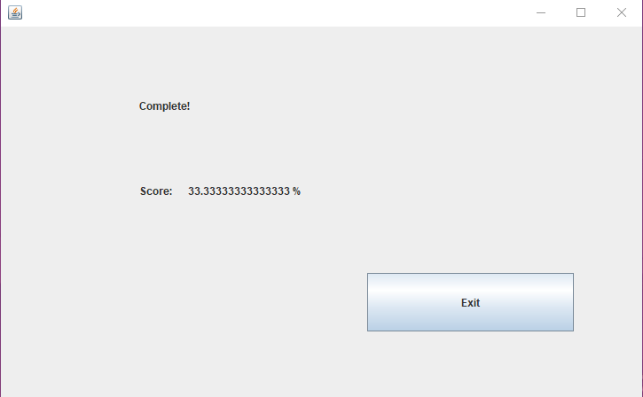

Figure 7 – Final score for Use Case 1 was 1 out of 3

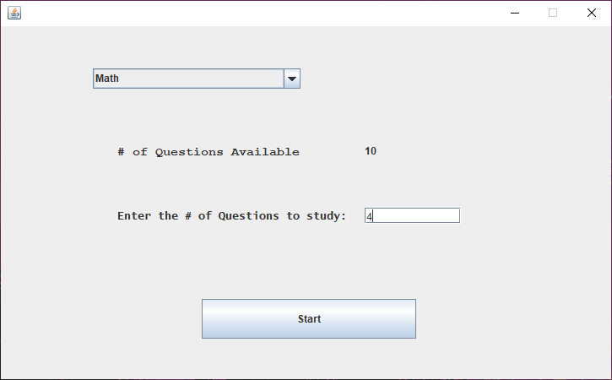

Figure 8 – Use Case 2 Setup

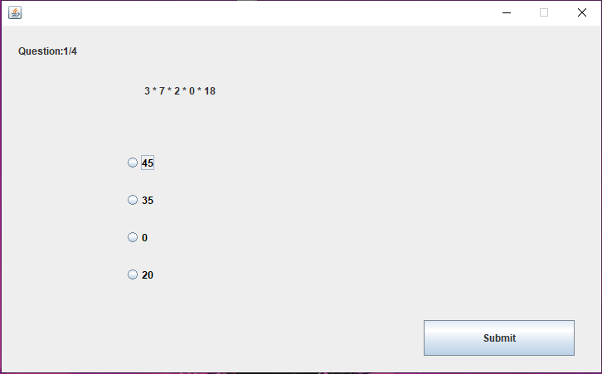

Figure 9 – Question 1/4 for Use Case 2 with no answer selected for Use Case 2

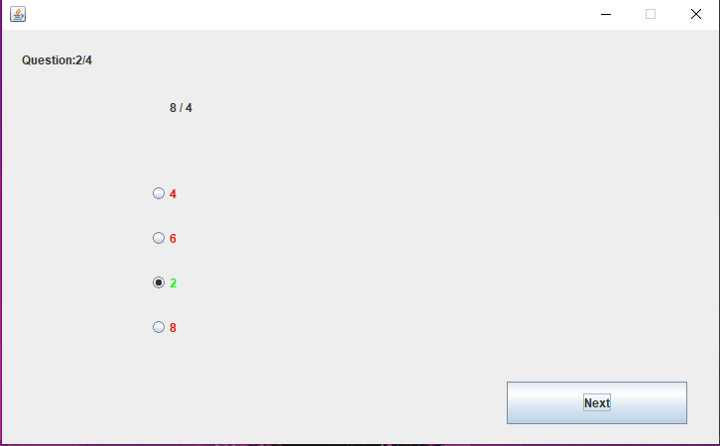

Figure 10 – Question 2/4 with the correct answer submitted for Use Case 2

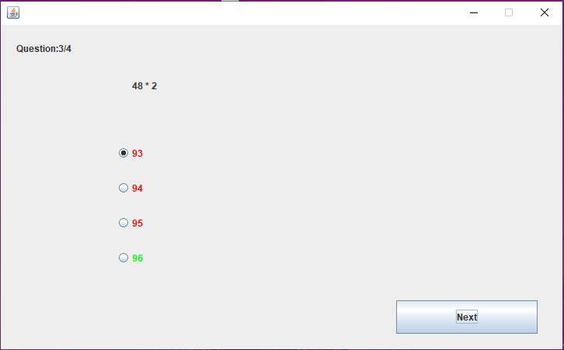

Figure 11 – Question 3/4 with the correct answer submitted for Use Case 2

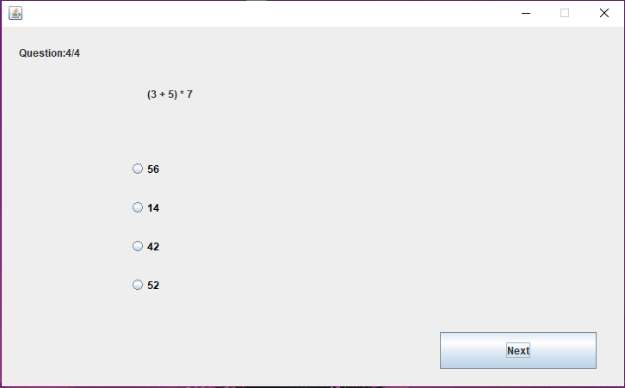

Figure 12 – Question 4/4 with no answer selected for Use Case 2

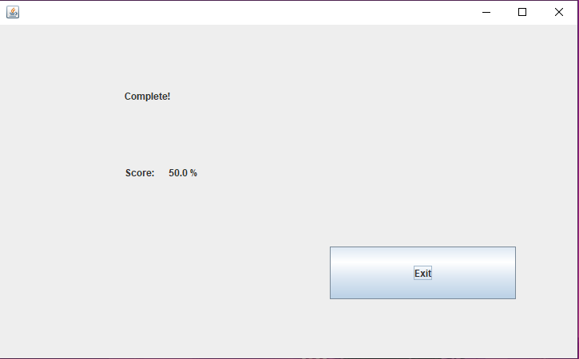

Figure 13 – Final score for Use Case 2 was 2/4

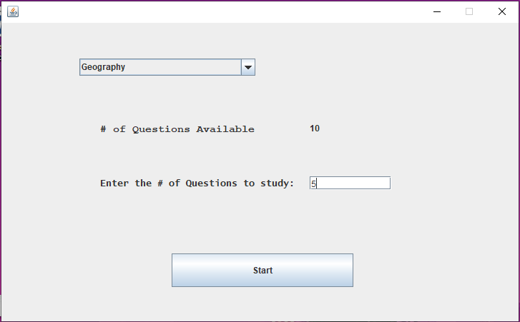

Figure 14 – Use Case 3 Setup

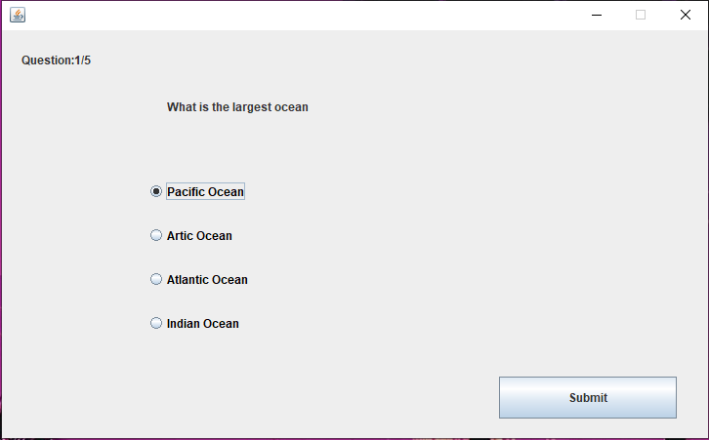

Figure 15 – Question 1/5 without an answer selected for Use Case 3

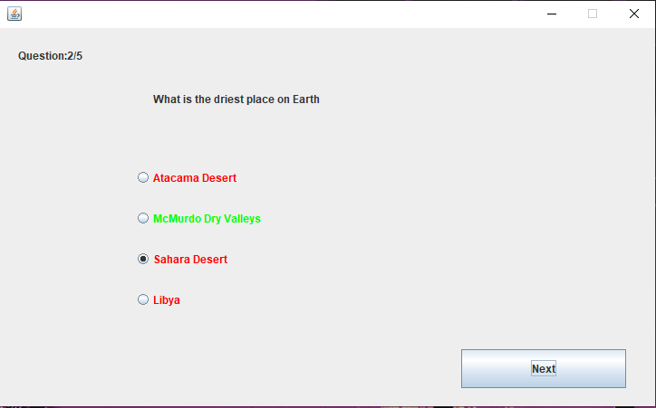

Figure 16 – Question 2/5 with incorrect answer submitted for Use Case 3

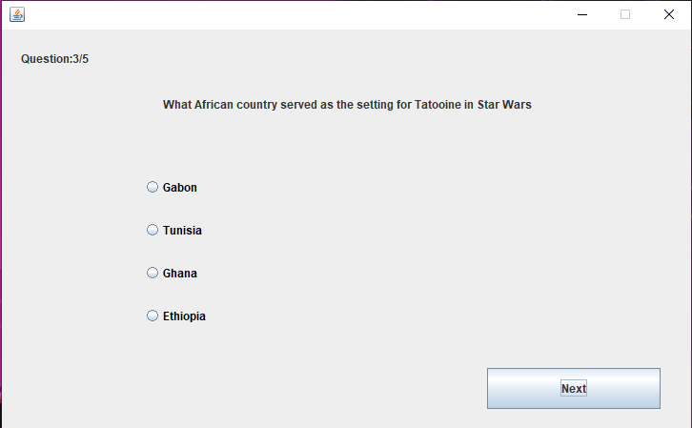

Figure 17 – Question 3/5 with no answer selected for Use Case 3

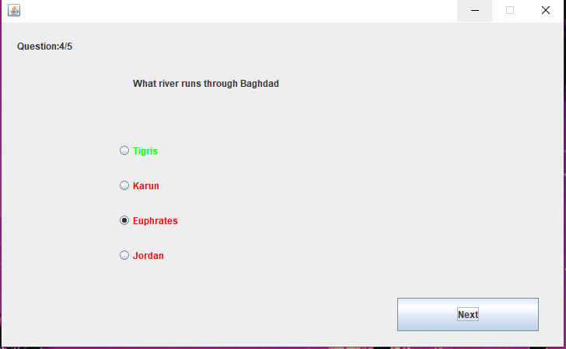

Figure 18 – Question 4/5 with incorrect answer submitted for Use Case 3

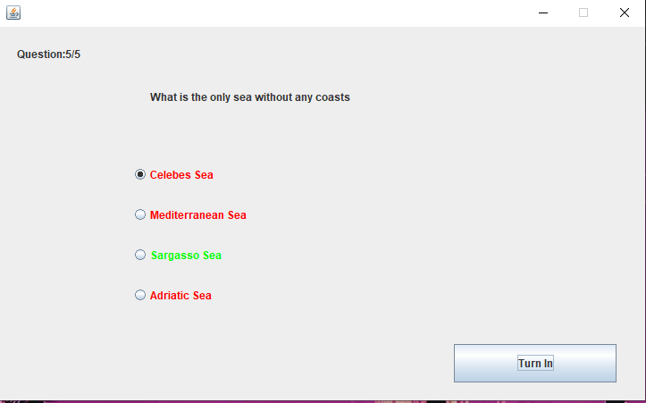

Figure 19 – Question 5/5 with incorrect answer submitted for Use Case 3

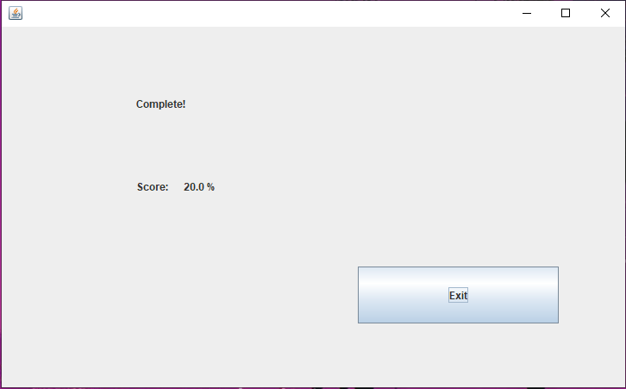

Figure 20 – Use Case 3 completed with a final score of 1/5 questions correct

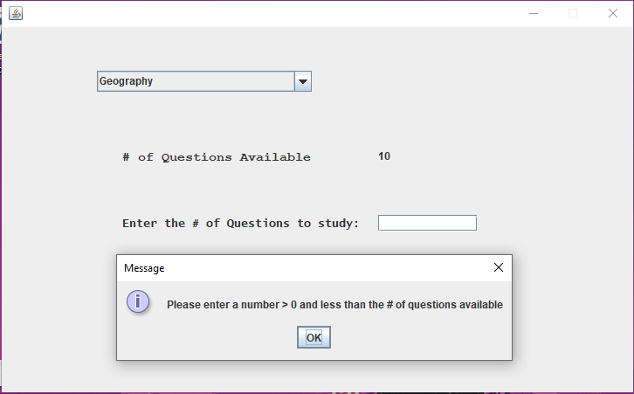

Figure 21 – Error Handling 1 Test of blank number of questions to study

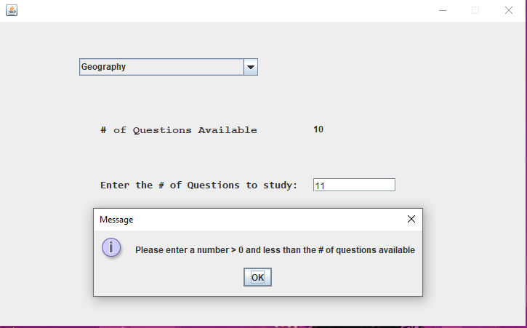

Figure 22 – Error Handling 1 test of more than available questions to study from

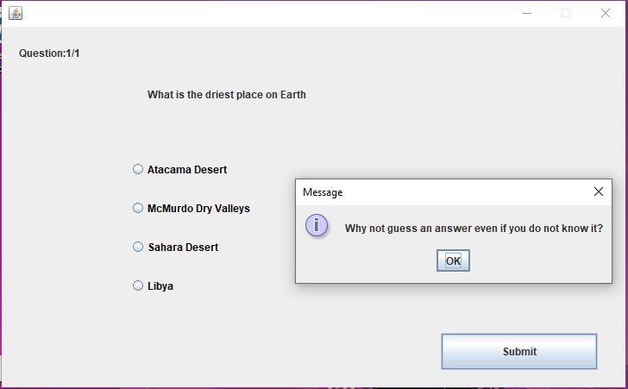

Figure 23 – Error Handling 1 test of pressing submit without selecting an answer

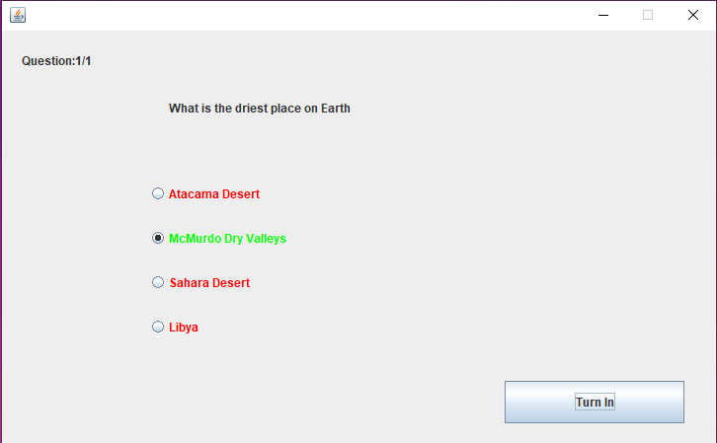

Figure 24 – Error Handling 1 submission of correct answer

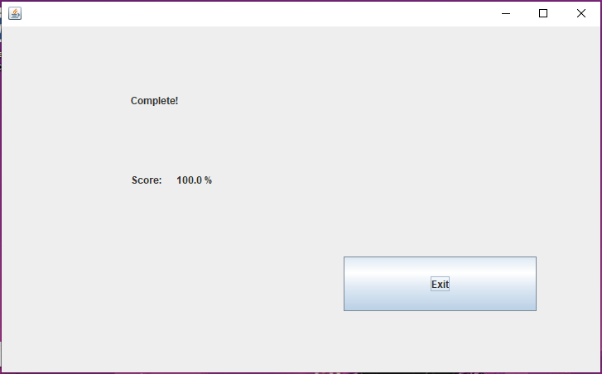

Figure 25 – Error Handling 1 test complete

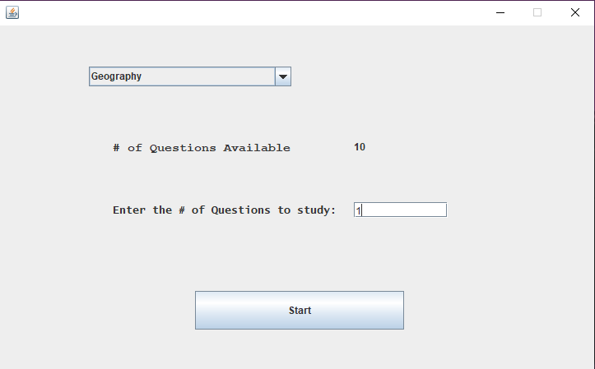

Figure 26 – Randomized Questions 1 Setup

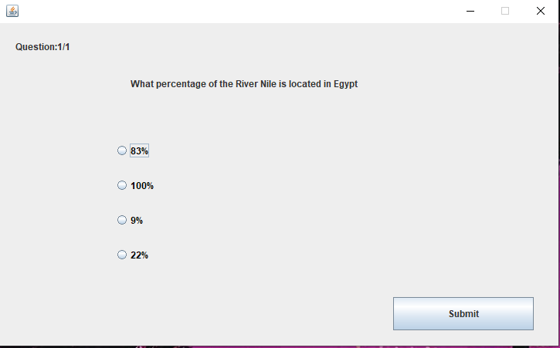

Figure 27 – Randomized Questions 1 first run through

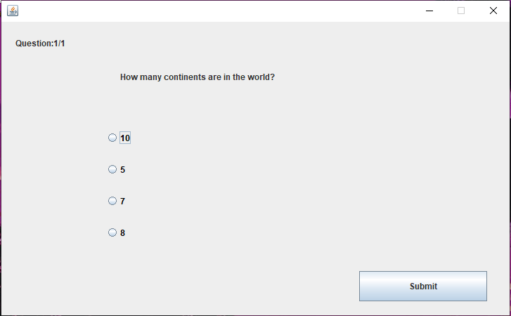

Figure 28 - Randomized Questions 1 second run through

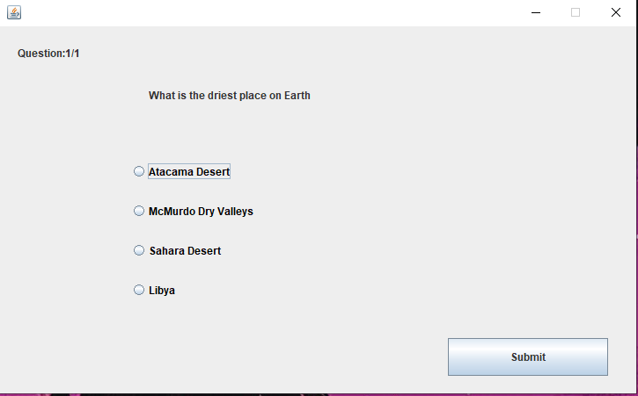

Figure 29 - Randomized Questions 1 third run through

Development History:

In week 2 after the group was finalized, each member submitted ideas for the Modular Study Application. The pool of features was rather large and fairly unrealistic to finish in the span of the class. We decided a Middleman class would handle the lifting of the database and the GUI and the database class and GUI class would be fairly light. This proved to be hard to pull off.

We shifted the design to more code in the GUI yet handling logic in the GUI code made for some bulky and unnecessary coding. It was at this point we chose to create Main.java to handle the initial GUI and logic as well as the database query. Database.java was created to maintain the connection with the database enabling Main to make the queries for the questions and answers.